**Infoblox Setup Guide**

Infoblox is an IP address and DNS management tool that is commonly deployed in large IT departments. Often,it is used in conjunction with Vmware or other private clouds for ip allocationa and de allocation.

**Installation:**

Below are the steps to install Infoblox Ipam:

1. Download the infoblox ova file using the below link,

<https://www.infoblox.com/infoblox-download-center/>

1. Import ova file for DDI [DNS, DHCP, and IP address management] evaluation copy into VMware ESX/Work station.
2. While deploying ova file configure the storage and disk format based on your requirement configuration.

For example:

* + - Deployment configuration: TE-815
    - Disk format: Thin provision

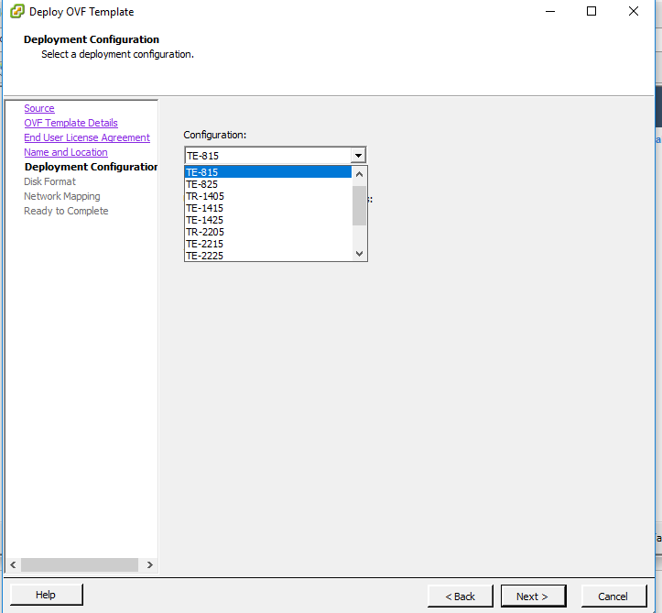

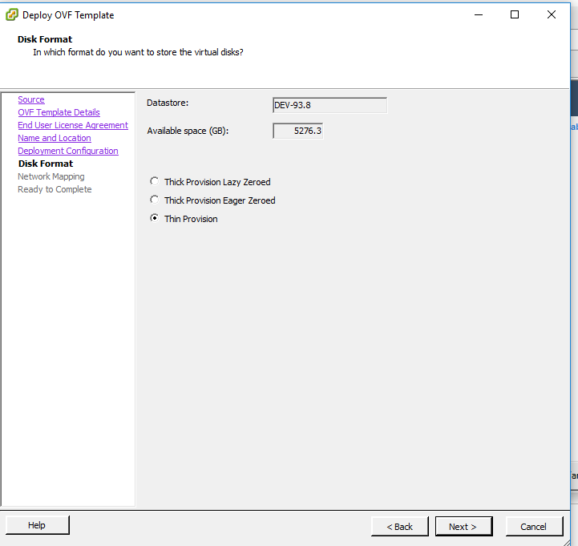

1. After installation is done, It will take around 10-15 mins to get initialized and pre -configured.
2. Power on the infoblox instance in VMware. Launch the web console from Vsphere
3. For configuring the network setup and license for infoblox , login with following default admin credentials as below
   * User: admin
   * Password: infoblox
4. After successful login, configure the network by typing **“set network”** command.
   * Give your **IP address** which is free in your network
   * Give **Netmask address** and **Gateway address** of the selected IP address
   * Enter “**n”** for not configuring ipv6 address
   * Enter “**n**” for not configuring grid master

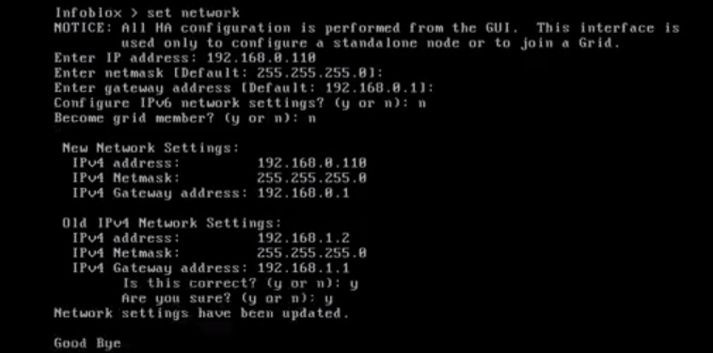

1. System will restart after configuring the network
2. Once restart completes, confirm network configuration using command **'show network**'.
3. Setting up License:
   * Type in console: **'set temp_license**'
   * Enter **'2'** to add DNS zone with Grid license.

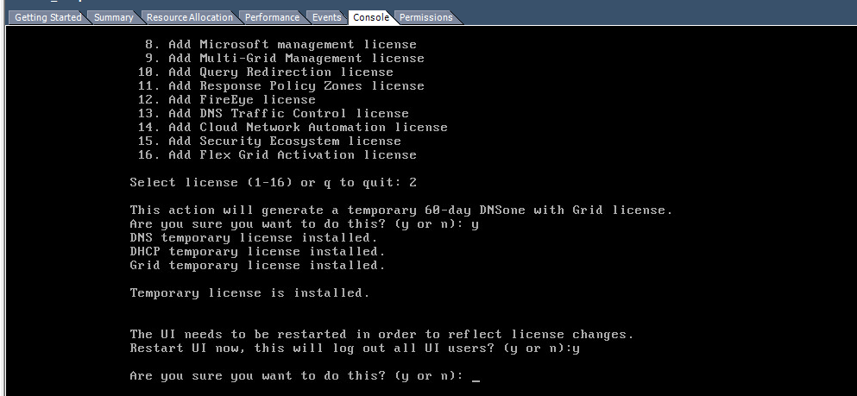

**Configuration:**

1. Open with infoblox server application with the Private Ip of the VM created for infoblox.
2. Adding custom extra attributes in network,
   * + 1. To add custom extra attributes, navigate to administrator menu and click on extra attributes then click ‘+’ to add your own attributes.

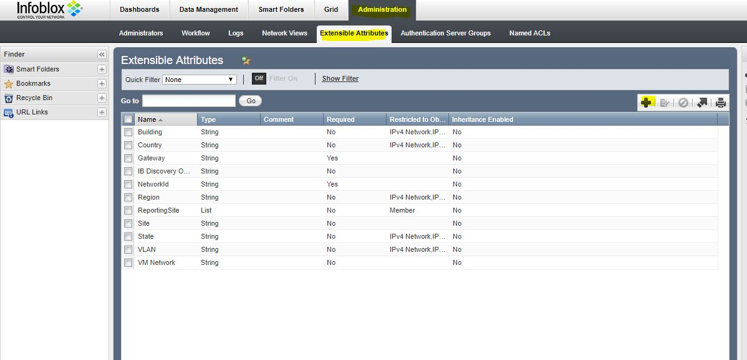

* + - 1. After adding the new external attributes, add the required attributes wherever required.

**For example**: If you want to add in network then open Ipam menu in

datamanagement tool and as shown the symbol in

yellow color in the below image click on that and select

external attributes to add the new attributes.

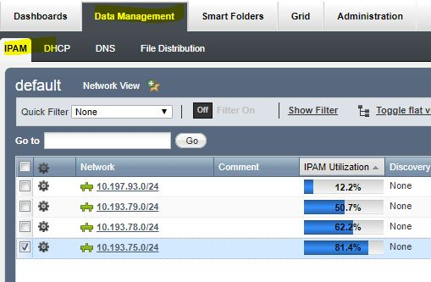

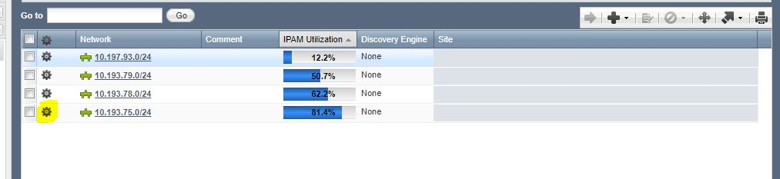

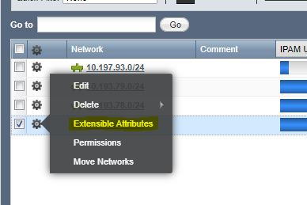

1. Adding Name Server Group in DNS,

Follow the below process,

* + - 1. Open DNS in Data Management and open Name server Groups and then click on the ‘+’ symbol to add.

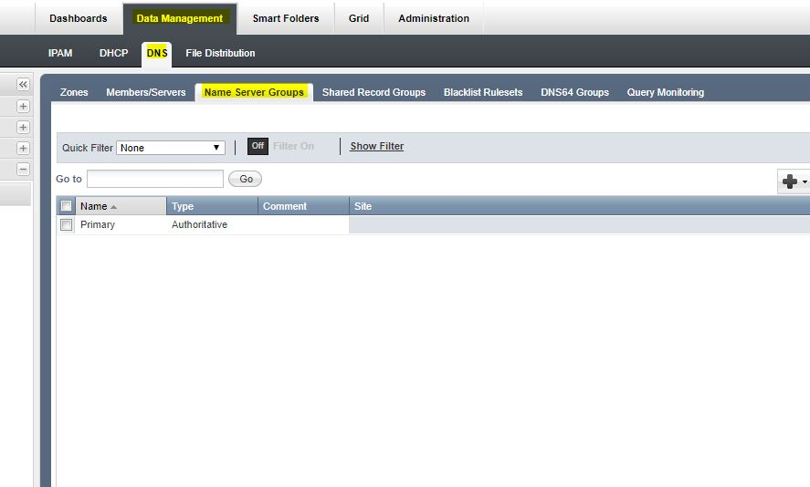

* + - 1. Give the name and select the ‘+’ to add the grid member.

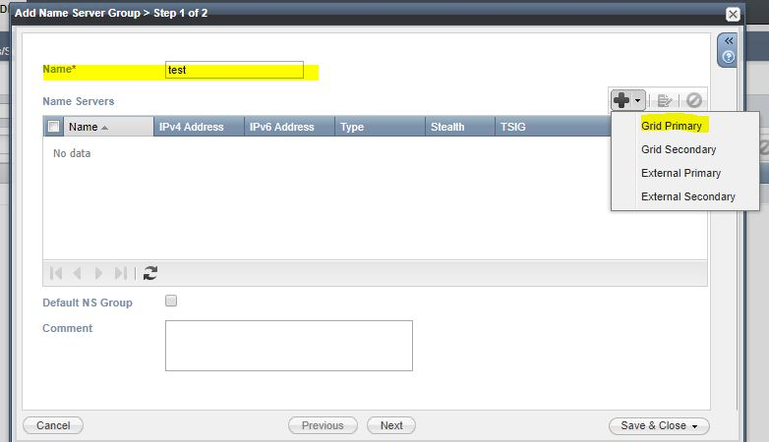

* + - 1. Click select button to select the grid member and click Add button.

After adding make it as default NS Group.

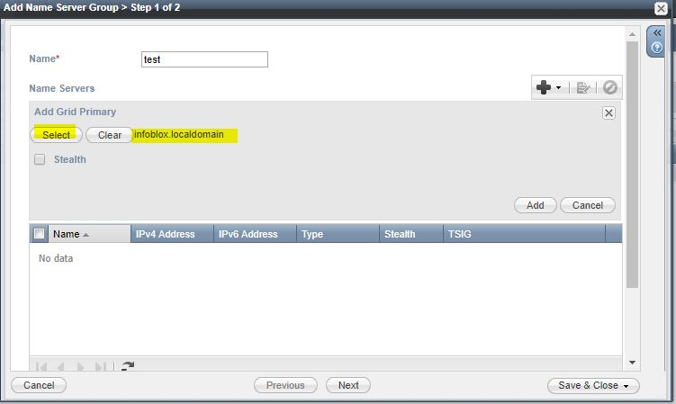

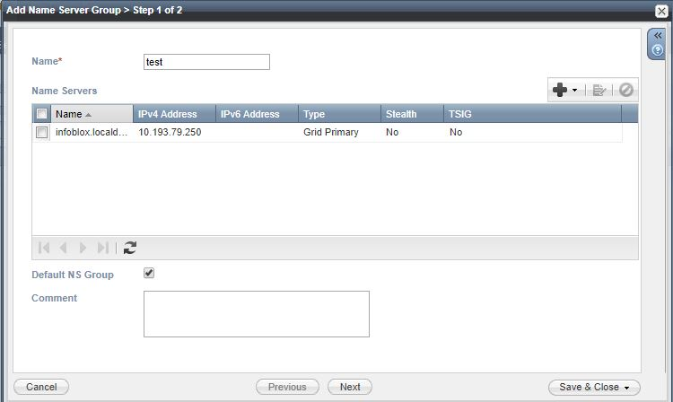

Click Save & Close or click next to add external attributes if required.

1. Adding Zones in DNS,
   * + 1. Click ‘+’ to add zones

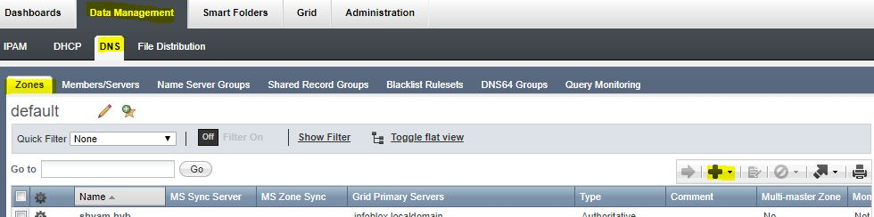

* + - 1. Select the first option,

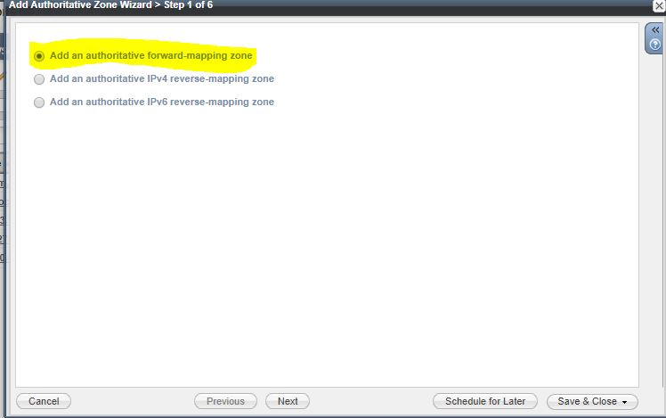

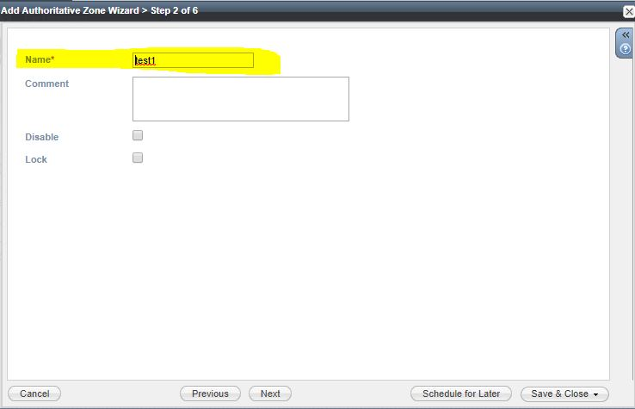

* + - 1. User the name server group created before,

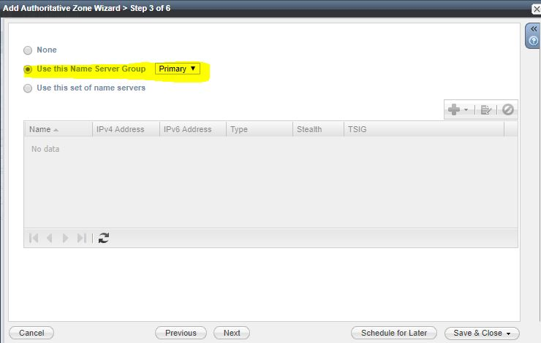

* + - 1. Save & Close the window.

1. Creating the Ipv4 network,
   * + 1. Open Ipam in Datamanagement and click the ‘+’ symbol to create the ipv4 network.

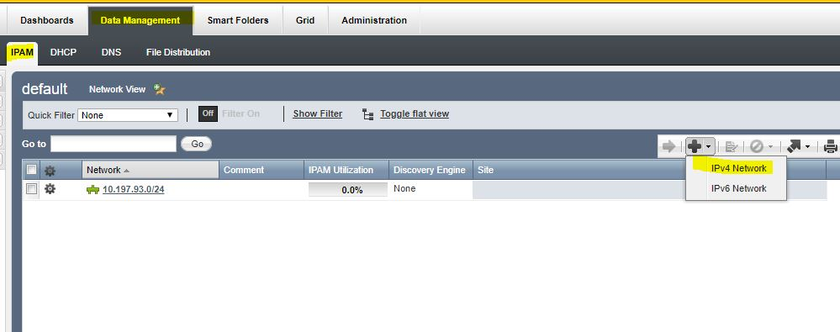

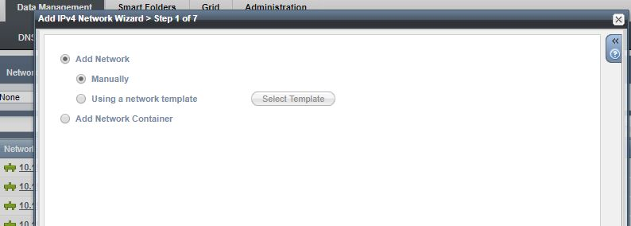

* + - 1. Click next.

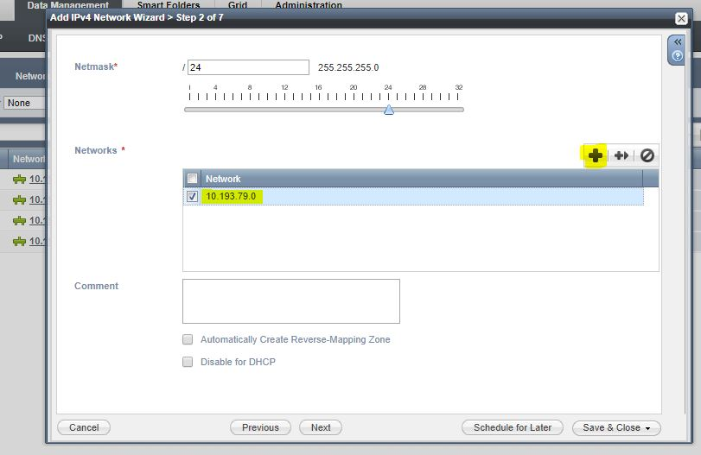

* + - 1. Click next to add domain name i.e., step 5, after adding the network ip.

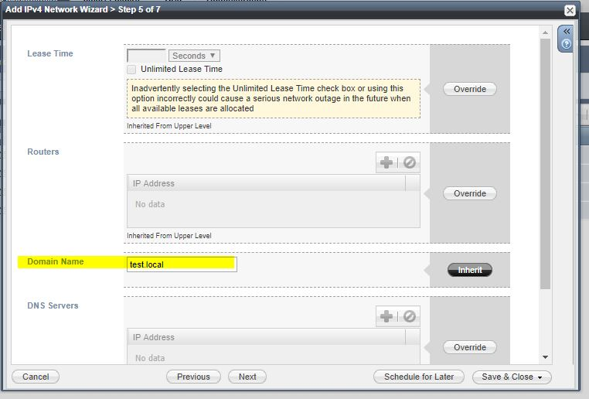

* + - 1. Click next to add the external required attributes,

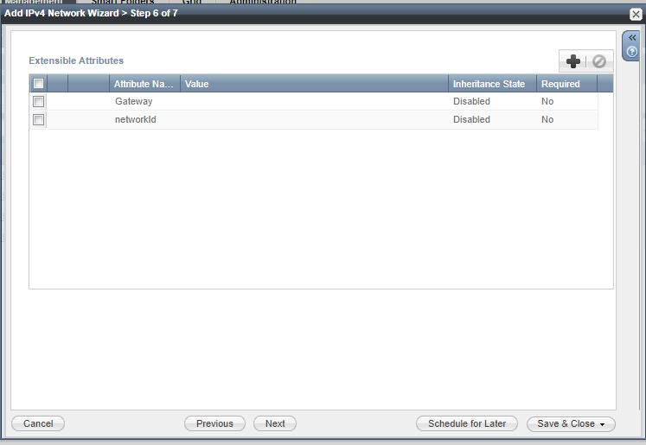

* + - 1. Save & Close the window.